Co-Operative Systems Audit Template – INTERNET SHEET

Click on the Internet/Network Info command button

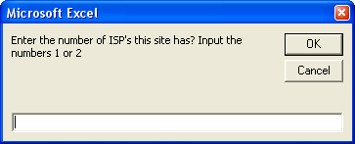
Once clicked it should show you this input box. Enter in the box 1 or 2 for the number of ISP’s a site has.

If you enter 1 then you see this below

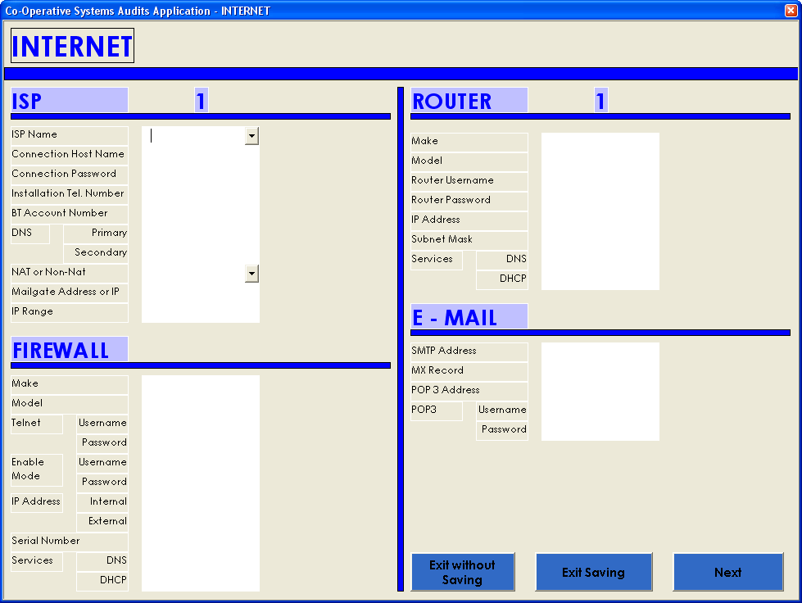
If you enter 2 then you see this below

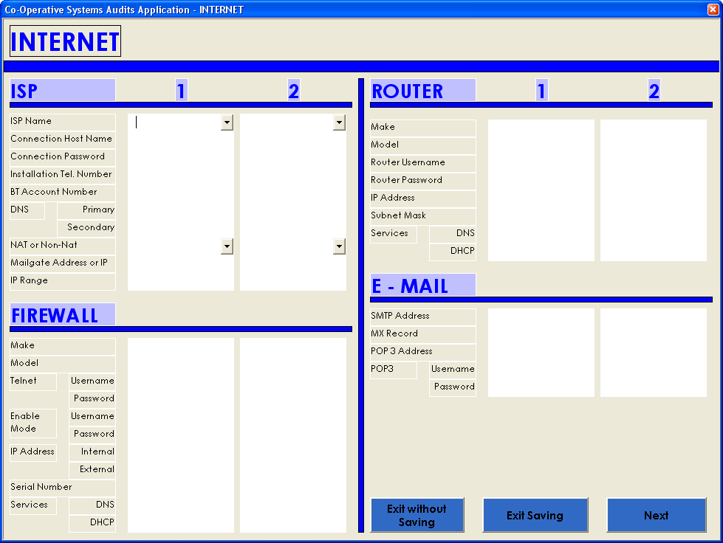
Enter the information that is requested, you can just click on next or exit the program. You have 2 options, save while exiting, or just exit without saving.

